MiSACWIS Project

PM01a – Maintain Additional Name UCR
Version 1.2

September 22, 2011

Prepared for:


120 N. Washington Square
SACWIS Project, 3rd Floor
Lansing, MI 48933

Prepared by:

Revision Log
Version | Date | A/D/C (Add, Delete, Change) | Author | Document Section # | Description
0.1 | 08/09/2011 |  | Pam Rasher |  | Initial version
1.0 | 09/22/2011 |  | P. Rasher |  | Approved
1.1 | 09/21/2011 | C | Swapnali Dashrath | 2 | Updated Class Diagrams
1.2 | 09/22/2011 | C | P. Rasher | 2, 4.1 | Quality Assurance Review. No functionality impact.
Table of Contents
1 Introduction 5
1.1 Purpose 5
1.2 Scope 5
2 Class Diagram 6
3 Sequence Diagram 7
4 Business Data Dictionary 8
4.1 CRUD Matrix 8

List of Figures
Figure 1 – Class diagram 6
Figure 2 – Sequence diagram 7

Introduction

Purpose
This document describes the process for creating, viewing, updating, and deleting a Person’s Additional Name information.

Scope
This document describes the technical design for the PM01a – Maintain Additional Name use case based on the screen specs created for the same use case.

Class Diagram

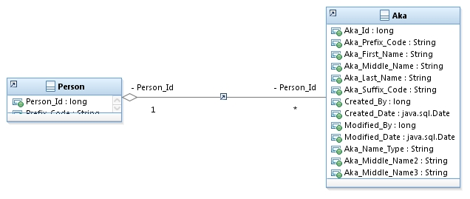
Figure 1 – Class diagram

Sequence Diagram
Figure 2 – Sequence diagram

Business Data Dictionary

CRUD Matrix
Class | Create | Read | Update | Delete
AKA | X | X | X | X
PERSON |  | X

